DAY 1
Task 2: Git Installation & Setup
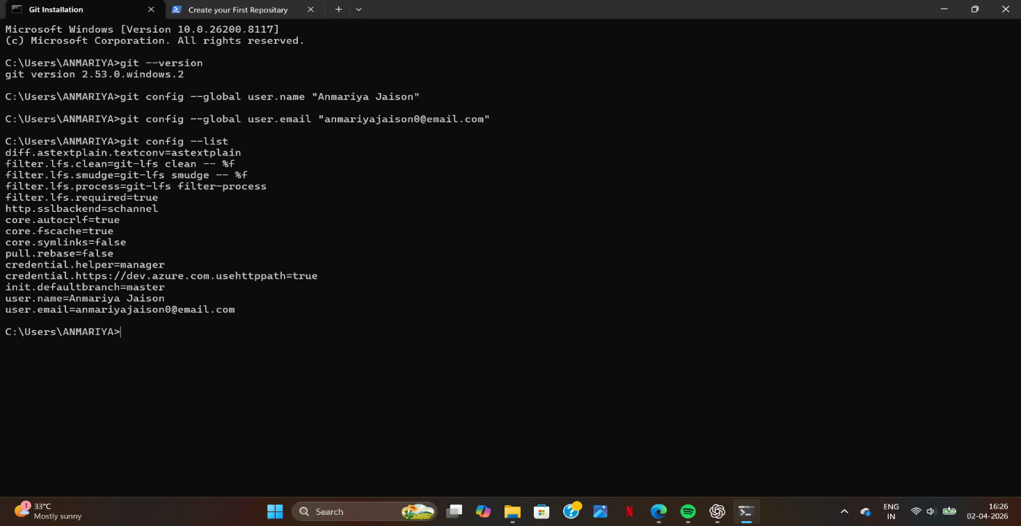
Task 3: Create Your First Repository
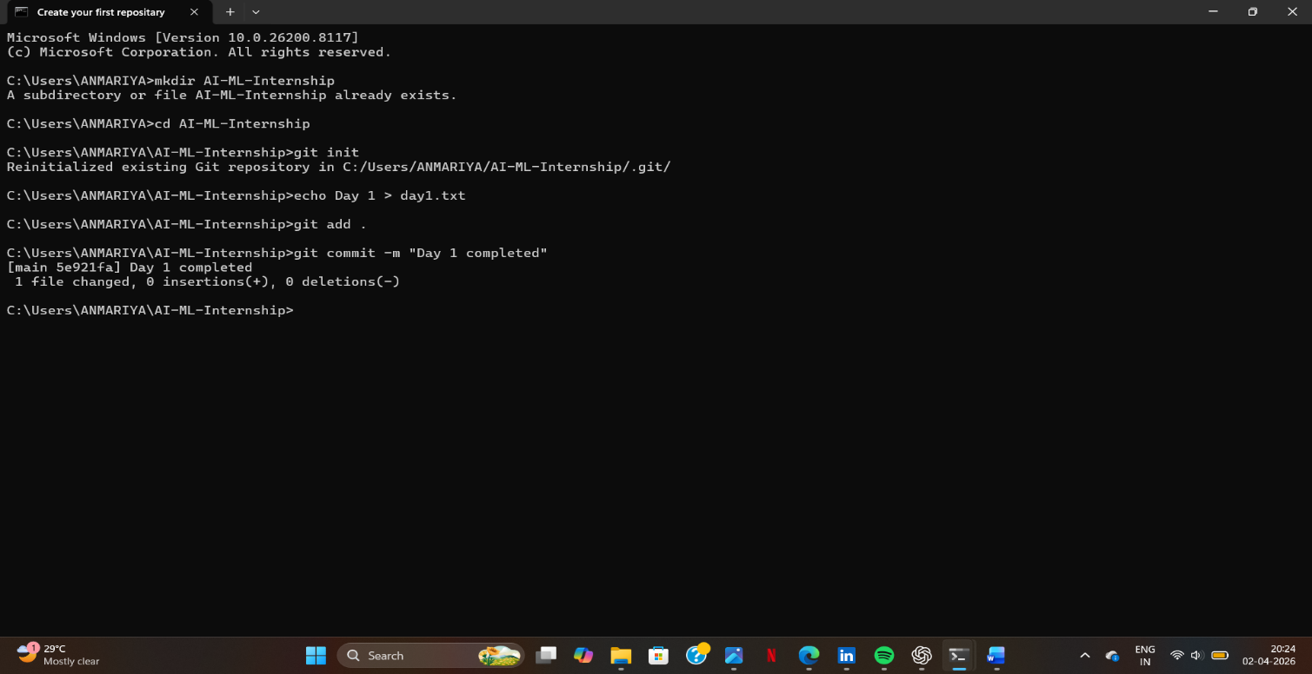
Task 4: GitHub Account
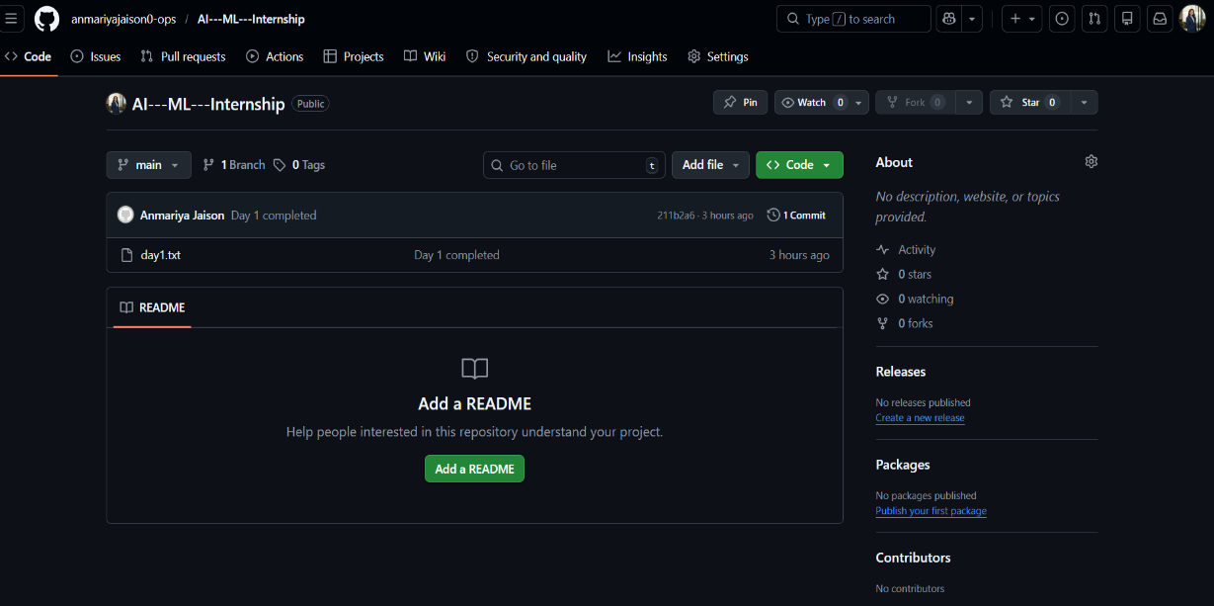
Link: https://github.com/anmariyajaison0-ops/AI---ML---Internship.git
Task 5: Research Task
1) AI vs ML vs Deep Learning
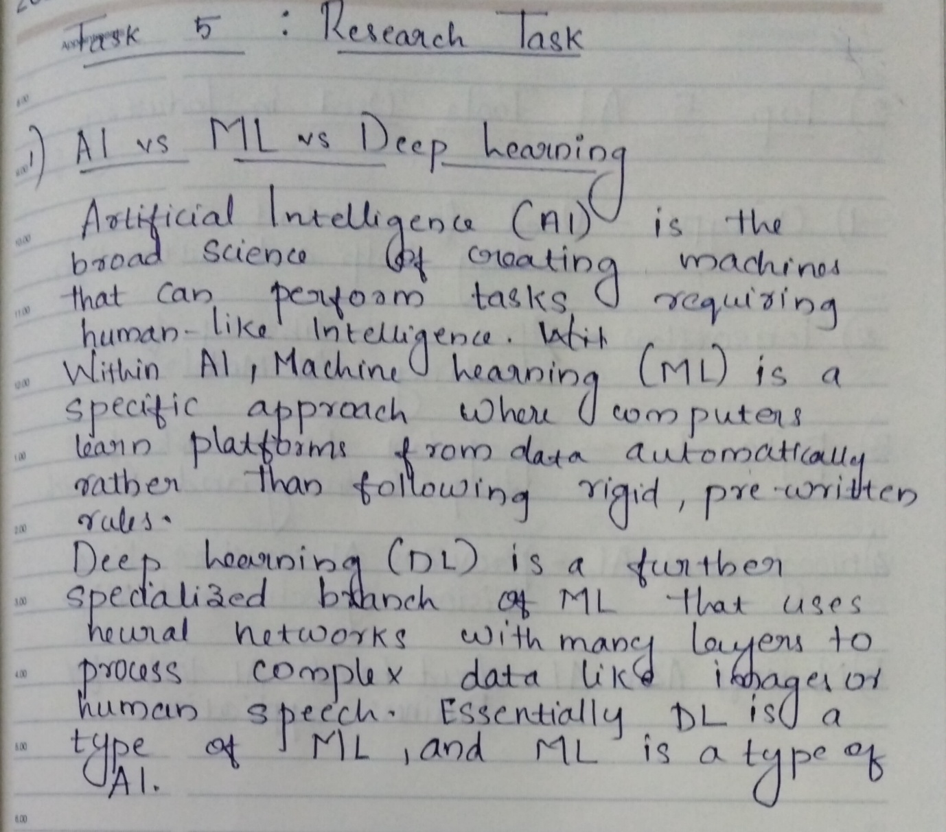
2) Top 5 AI tools used in industry
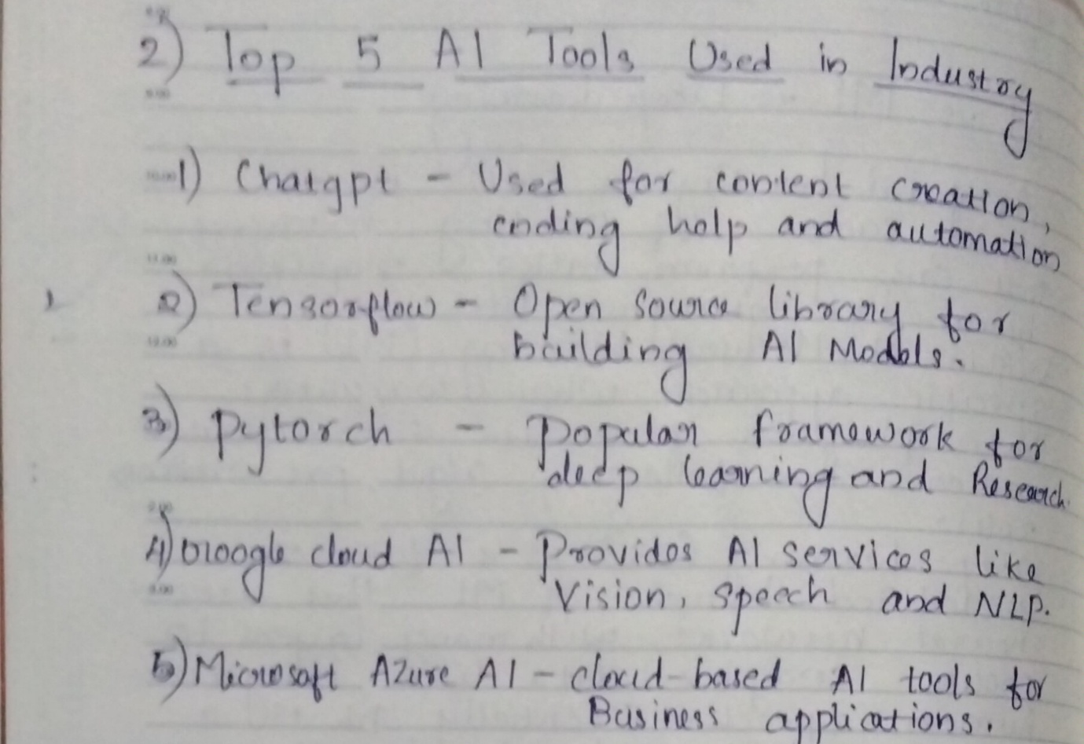
Task 6: Practical Thinking Task
If you build an AI project, what problem will you solve and how
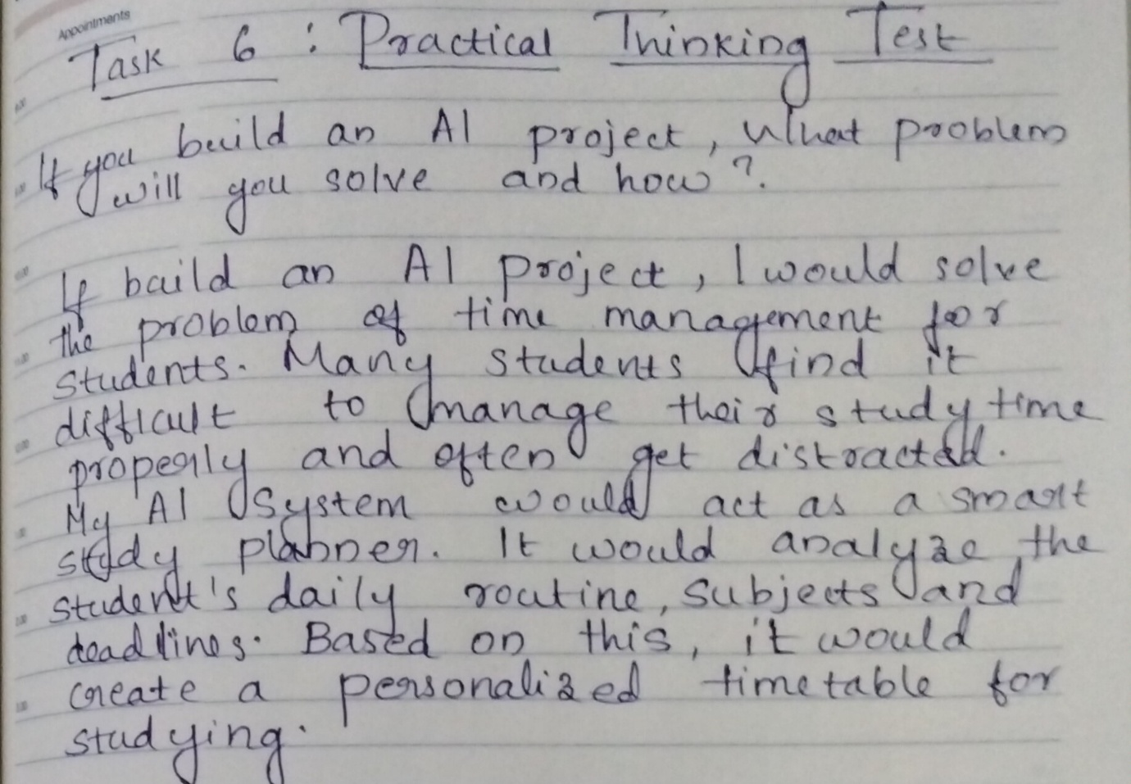
Task 7: Bonus Task
